International Conference on GIS and Geoinformation

Zoning for Disaster Mitigation (GIZ)

Analysis of interaction of precast concrete joint piles with problematic soil conditions Prorva

**A.R Omarov**

*L.N. Gumilyov Eurasian National University, Astana, Kazakhstan* [*omarov_01@bk.ru*](mailto:omarov_01@bk.ru)

**A.Zh. Zhussupbekov**

*L.N. Gumilyov Eurasian National University, Astana, Kazakhstan*

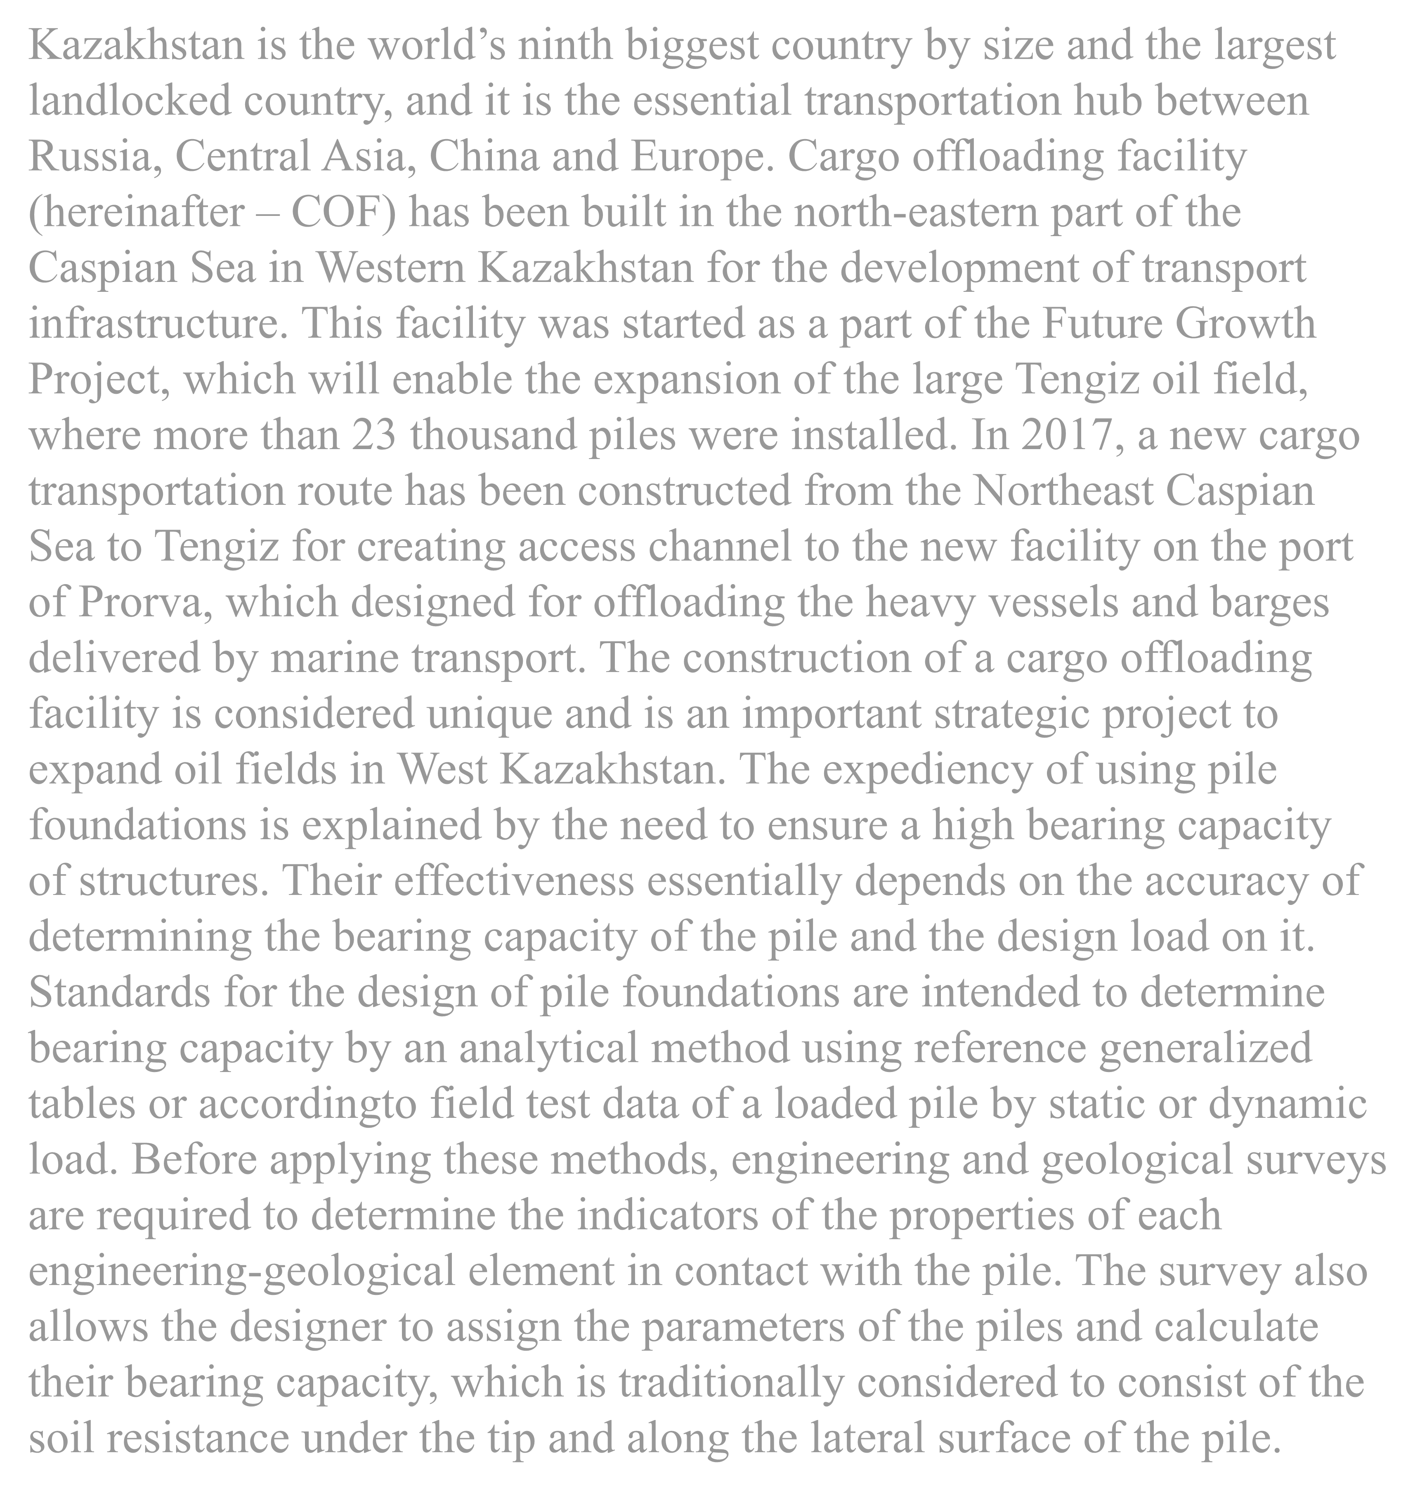

Kazakhstan is the world’s ninth biggest country by size and the largest landlocked country, and it is the essential transportation hub between Russia, Central Asia, China and Europe. Cargo offloading facility (hereinafter – COF) has been built in the north-eastern part of the Caspian Sea in Western Kazakhstan for the development of transport infrastructure. This facility was started as a part of the Future Growth Project, which will enable the expansion of the large Tengiz oil field, where more than 23 thousand piles were installed. In 2017, a new cargo transportation route has been constructed from the Northeast Caspian Sea to Tengiz for creating access channel to the new facility on the port of Prorva, which designed for offloading the heavy vessels and barges delivered by marine transport. The construction of a cargo offloading facility is considered unique and is an important strategic project to expand oil fields in West Kazakhstan. The expediency of using pile foundations is explained by the need to ensure a high bearing capacity of structures. Their effectiveness essentially depends on the accuracy of determining the bearing capacity of the pile and the design load on it.

Standards for the design of pile foundations are intended to determine

bearing capacity by an analytical method using reference generalized tables or accordingto field test data of a loaded pile by static or dynamic load. Before applying these methods, engineering and geological surveys are required to determine the indicators of the properties of each engineering-geological element in contact with the pile. The survey also allows the designer to assign the parameters of the piles and calculate their bearing capacity, which is traditionally considered to consist of the soil resistance under the tip and along the lateral surface of the pile.

**Introduction**

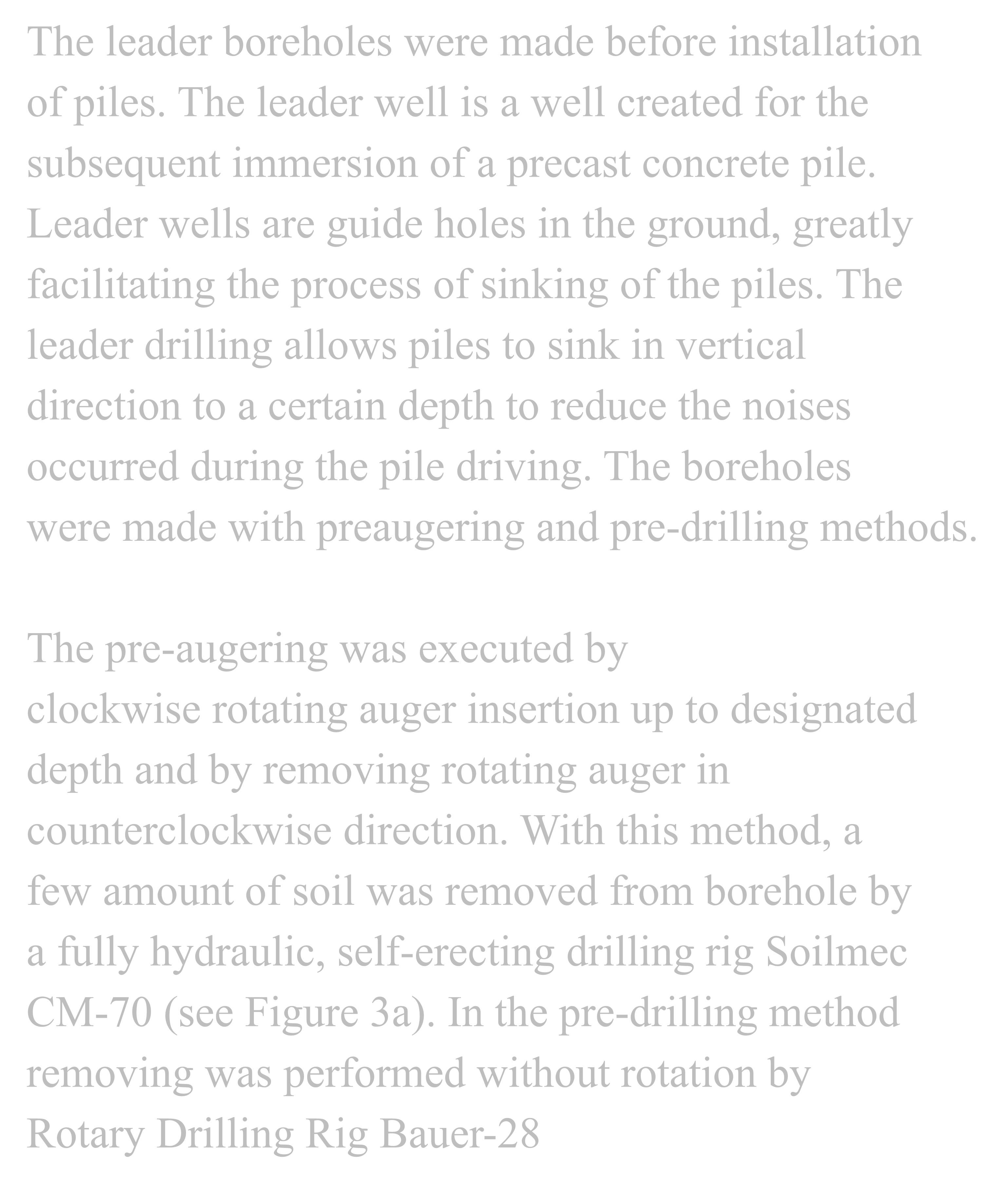

The pre-augering was executed by

clockwise rotating auger insertion up to designated depth and by removing rotating auger in counterclockwise direction. With this method, a few amount of soil was removed from borehole by a fully hydraulic, self-erecting drilling rig Soilmec CM-70 (see Figure 3a). In the pre-drilling method removing was performed without rotation by Rotary Drilling Rig Bauer-28

The leader boreholes were made before installation of piles. The leader well is a well created for the subsequent immersion of a precast concrete pile.

Leader wells are guide holes in the ground, greatly facilitating the process of sinking of the piles. The leader drilling allows piles to sink in vertical direction to a certain depth to reduce the noises occurred during the pile driving. The boreholes

were made with preaugering and pre-drilling methods.

**Installation of precast concrete joint piles**

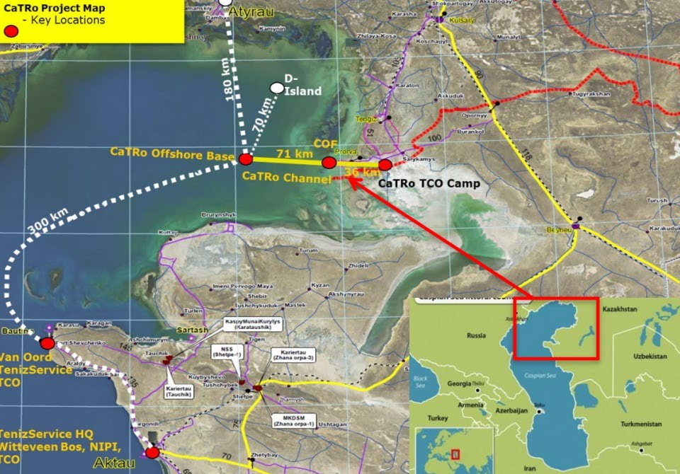

**Location of Cargo offloading facility**

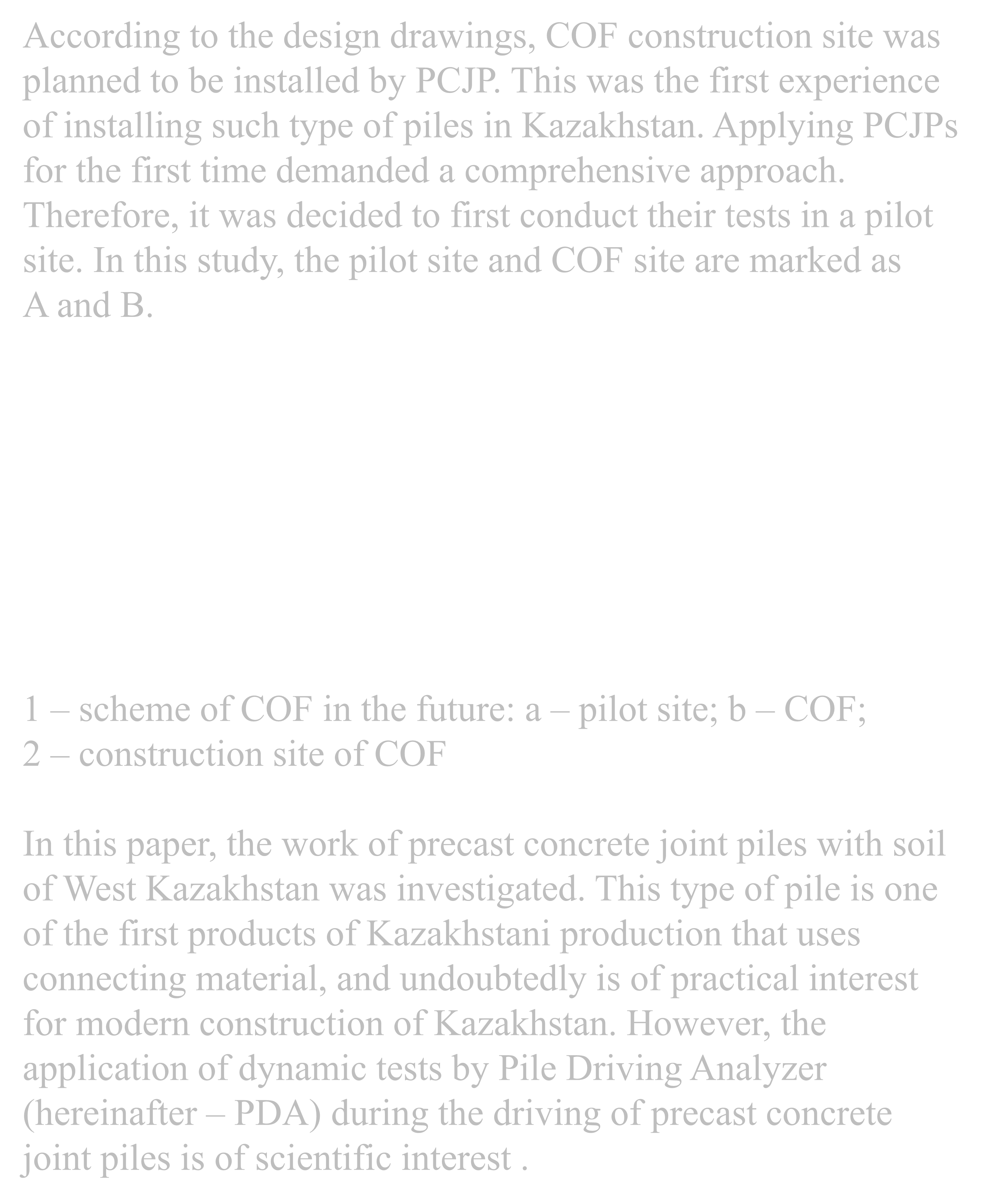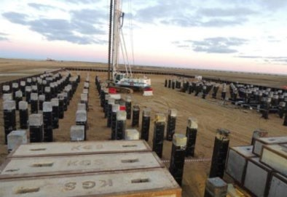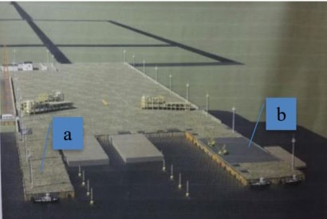

1. – scheme of COF in the future: а – pilot site; b – COF;
2. – construction site of COF

In this paper, the work of precast concrete joint piles with soil of West Kazakhstan was investigated. This type of pile is one of the first products of Kazakhstani production that uses connecting material, and undoubtedly is of practical interest for modern construction of Kazakhstan. However, the application of dynamic tests by Pile Driving Analyzer (hereinafter – PDA) during the driving of precast concrete joint piles is of scientific interest .

According to the design drawings, COF construction site was planned to be installed by PCJP. This was the first experience of installing such type of piles in Kazakhstan. Applying PCJPs for the first time demanded a comprehensive approach.

Therefore, it was decided to first conduct their tests in a pilot site. In this study, the pilot site and COF site are marked as A and B.

**Cargo Offloading Facility.**

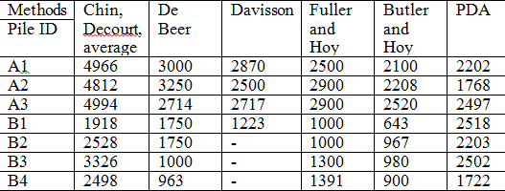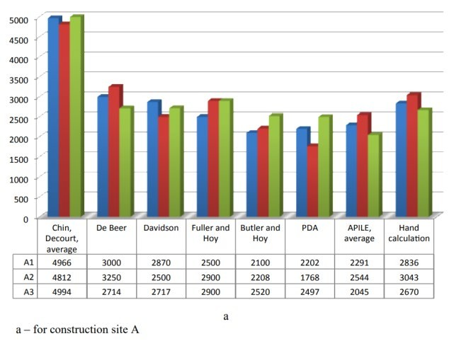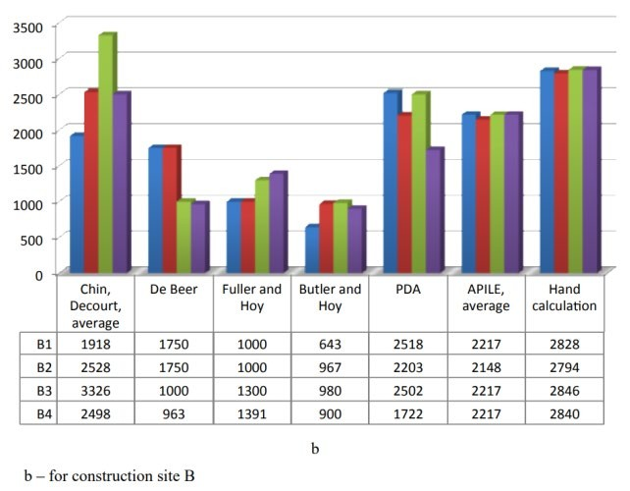

Comparison of pile capacities at construction sites A and B

**Discussions**

**CONCLUSIONS**

The interaction of precast concrete joint piles with the square section of 400*400 mm and with the length of 27.5 m with the surrounding soil ground during the construction of a port for offloading bulky goods were considered in this thesis. When assessing the reliability of a pile foundation, one of the determining ones is the question of the bearing capacity of the pile by soil. The greatest attention is paid to the bearing capacity of piles by static and dynamic load in classical and numerical and normative methods for identification of this parameter. The determination of the bearing capacity of precast concrete joint piles by interpretation methods, in the APILE software and by the SNiP formula presents particular interest to practicing engineers and scientists. The use of precast concrete joint piles during the construction of a cargo offloading facility in Western Kazakhstan in the Prorva

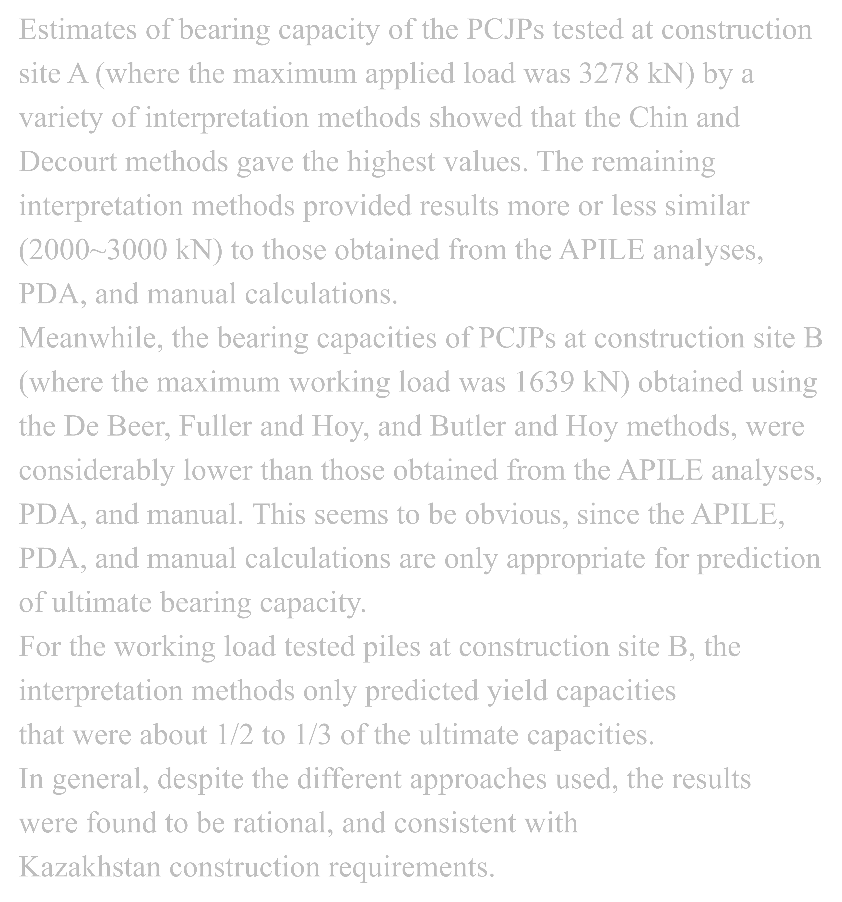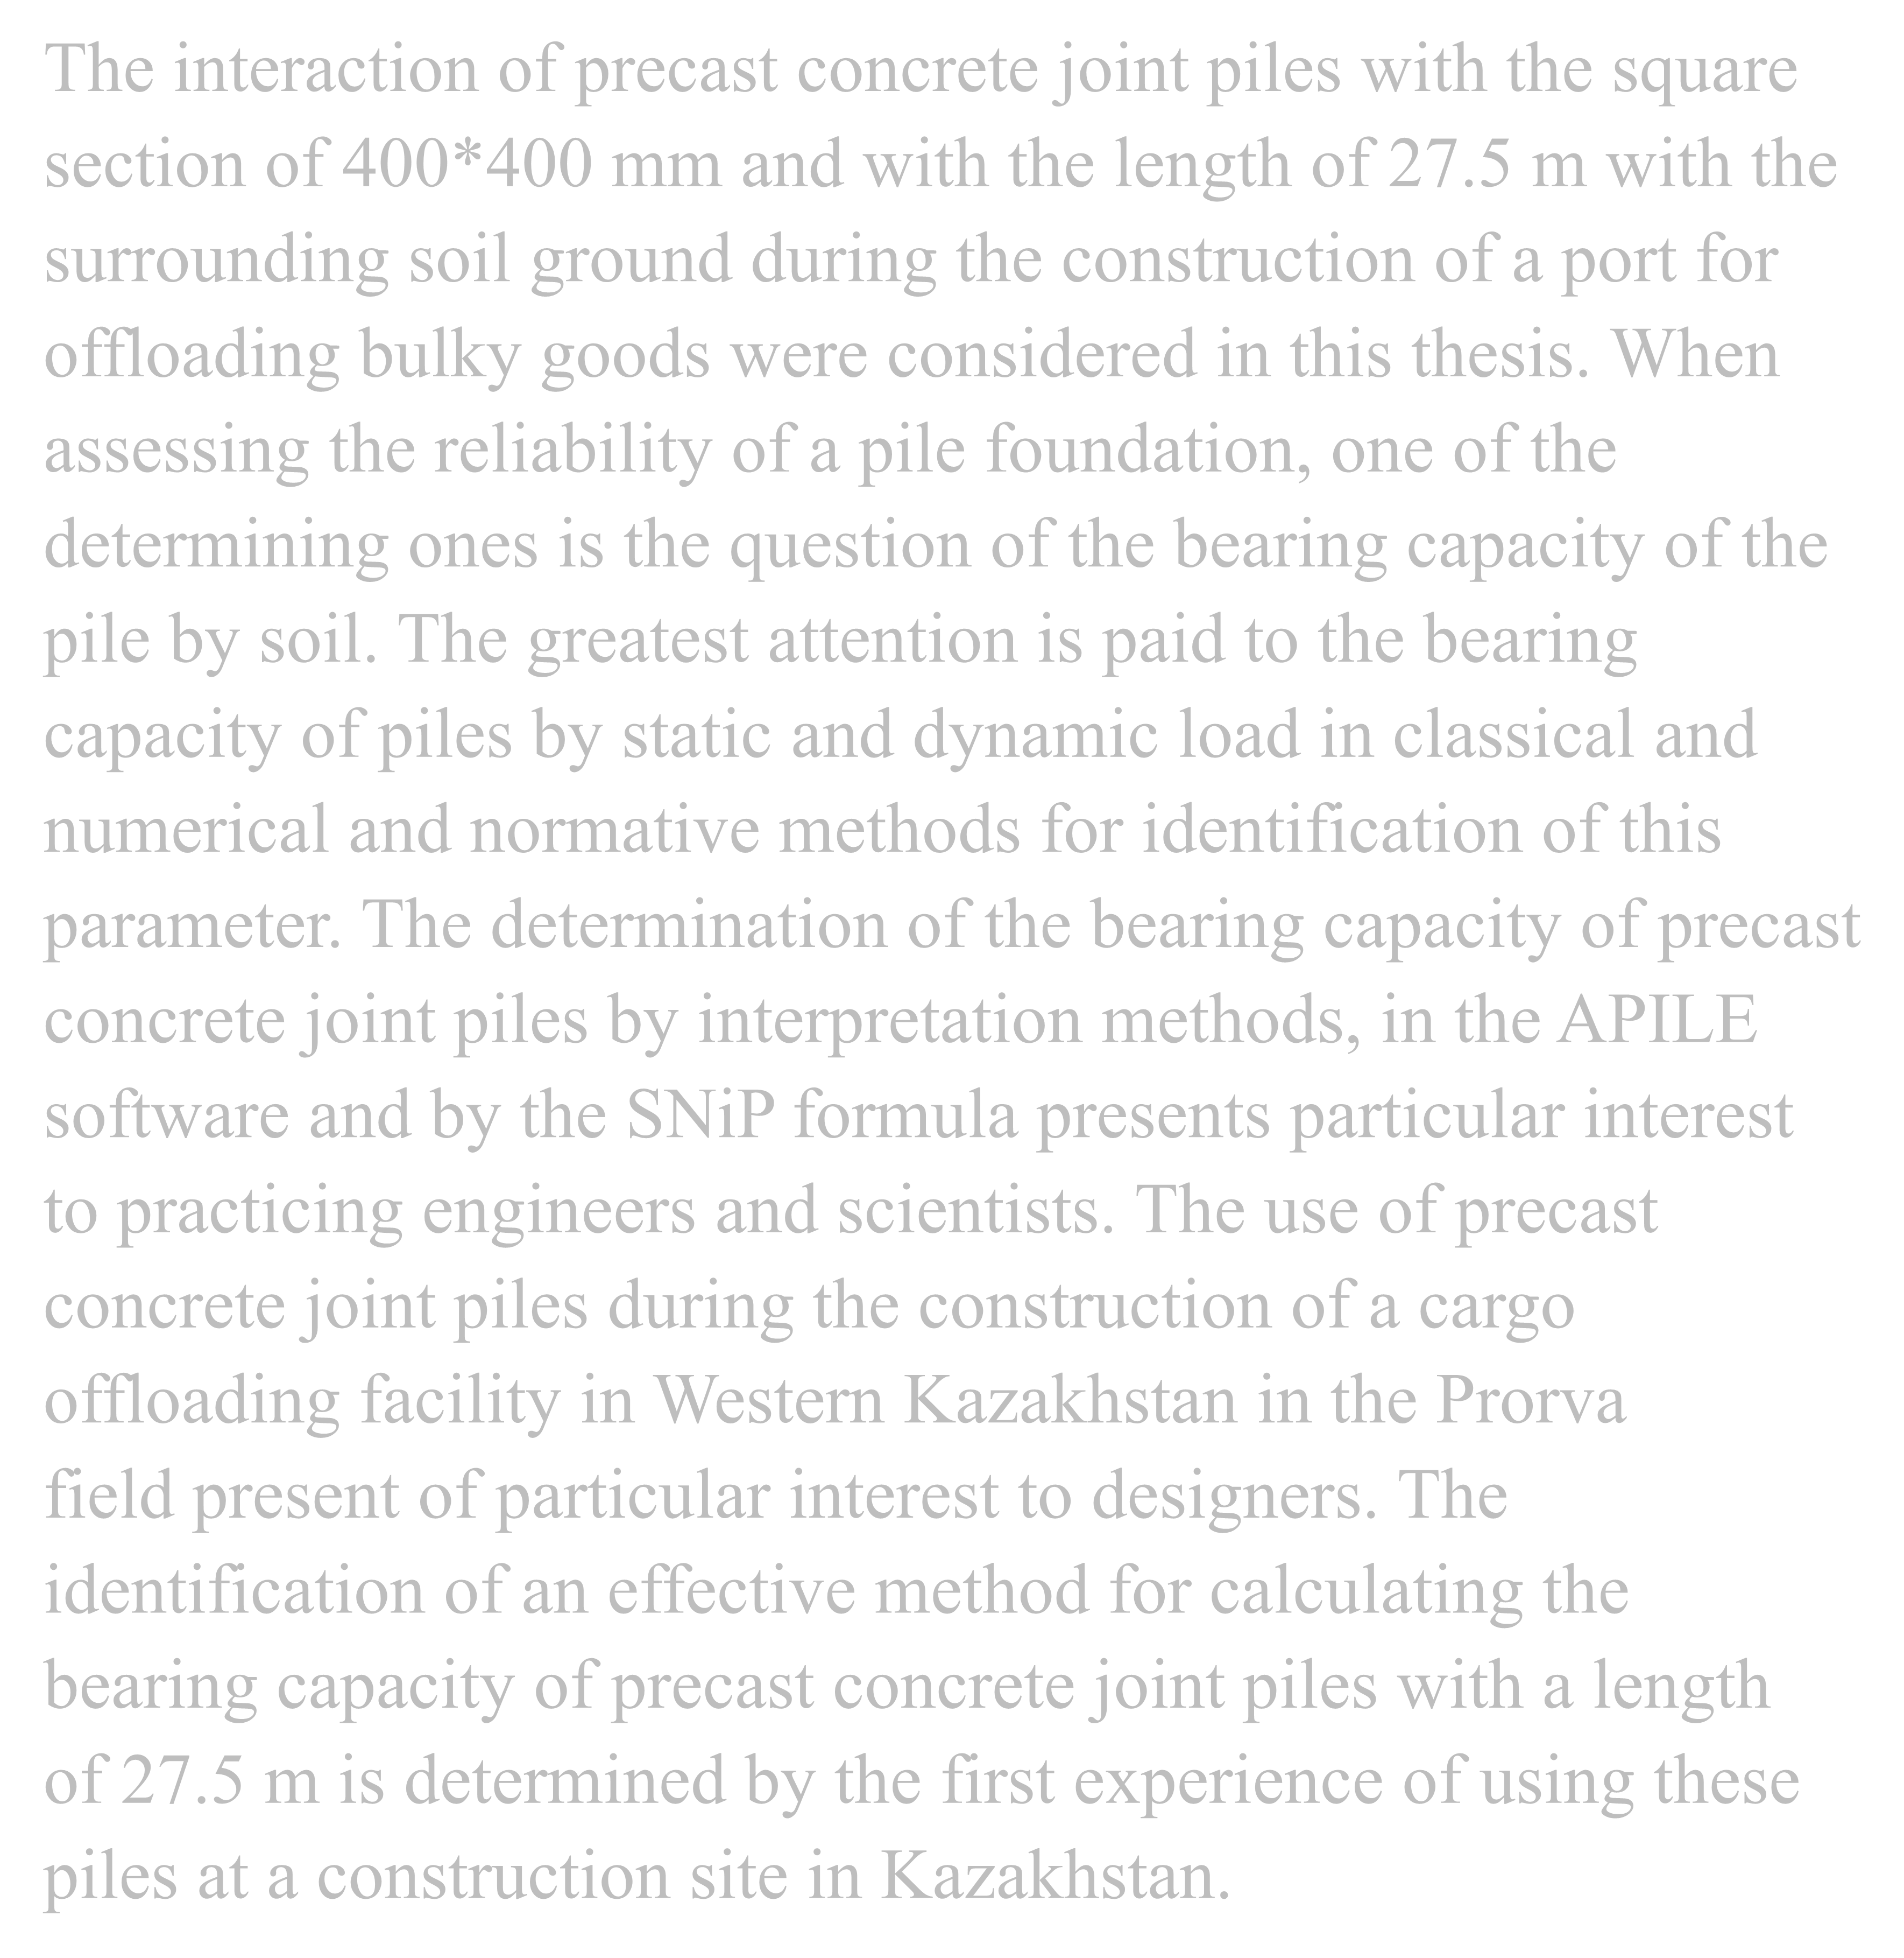

Estimates of bearing capacity of the PCJPs tested at construction site A (where the maximum applied load was 3278 kN) by a variety of interpretation methods showed that the Chin and Decourt methods gave the highest values. The remaining interpretation methods provided results more or less similar (2000~3000 kN) to those obtained from the APILE analyses, PDA, and manual calculations.

Meanwhile, the bearing capacities of PCJPs at construction site B (where the maximum working load was 1639 kN) obtained using the De Beer, Fuller and Hoy, and Butler and Hoy methods, were considerably lower than those obtained from the APILE analyses, PDA, and manual. This seems to be obvious, since the APILE, PDA, and manual calculations are only appropriate for prediction of ultimate bearing capacity.

For the working load tested piles at construction site B, the interpretation methods only predicted yield capacities

that were about 1/2 to 1/3 of the ultimate capacities.

In general, despite the different approaches used, the results were found to be rational, and consistent with

Kazakhstan construction requirements.

field present of particular interest to designers. The

identification of an effective method for calculating the bearing capacity of precast concrete joint piles with a length of 27.5 m is determined by the first experience of using these piles at a construction site in Kazakhstan.

Based on the results of this study the following recommendations are made.

1. According to the results obtained from the seven field tests of piles by dynamic and static loads at the construction site of Cargo offloading facilities and the pilot site, it is considered the dynamic tests by PDA for application of identification of bearing capacity of precast concrete joint pile. Because the results of PDA show the similarity with static loading test, analytical methods as APILE analysis and calculation by equation from Kazakhstani standard. Dynamic test by PDA is economical and time saving. Although SLT is reliable but this test is very expensive and time consuming, hence researchers have been trying to come up with other efficient approaches.
2. The bearing capacity of precast concrete joint pile from static loading test data can be determined by conventional methods as Davisson, Chin, De Beer, Fuller and Hoy, Butler and Hoy. However, they are more appropriate for interpretation of high static loading test data, where settlements are bigger.
3. Estimation of bearing capacity of precast concrete joint pile can be made by APILE analysis program and equation from Kazakhstani standard